Sales and Operational Analysis of Classical Automobile Using SQL

Project Brief
This project focuses on analyzing the Classical Automobile dataset using SQL queries to extract meaningful business insights. The dataset contains tables for customers, orders, employees, payments, products, and order details. The primary goal is to understand revenue trends, product performance, customer behavior, and employee productivity.

Tools Used
MySQL
SQL Workbench
Excel (for visualization or post-processing if needed)

Dataset Overview:
The dataset includes the following key tables:
- Customers – Customer information and locations.
- Employees – Staff details and reporting structure.
- Offices – Regional office details.
- Orders – Sales orders with status and dates.
- Order Details – Product-level breakdown of orders.
- Payments – Customer payment history.
- Product Lines – Categories of products.
- Products – Inventory of products sold.

Problem Statements
- 1. Identify total revenue generated per month.

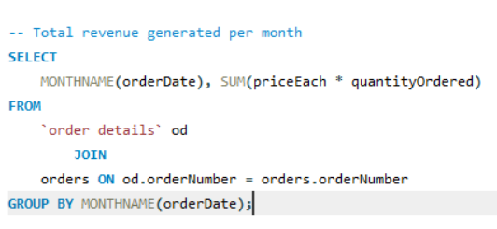

- 2. Determine the top five Product generating the highest revenue.

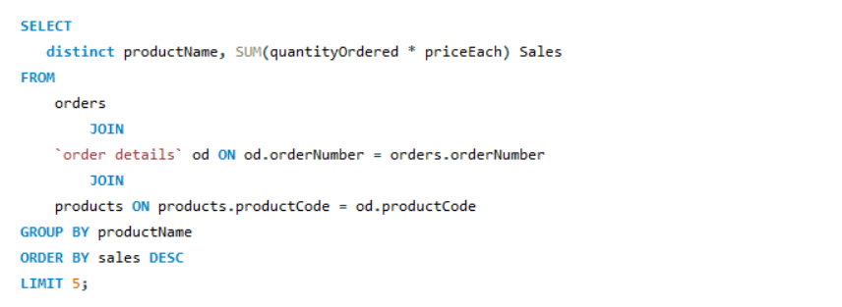

- 3. Find the top five customers with the highest total payments.

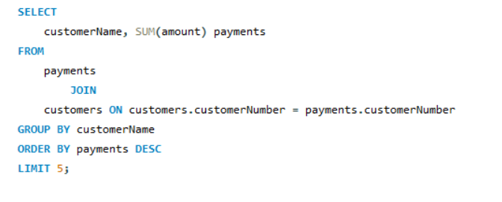

- 4. Analyze revenue generated from each office location.

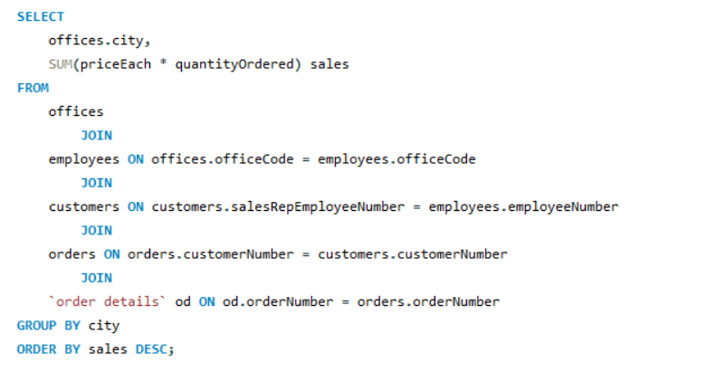

- 5. Identify the top five most frequently ordered products.

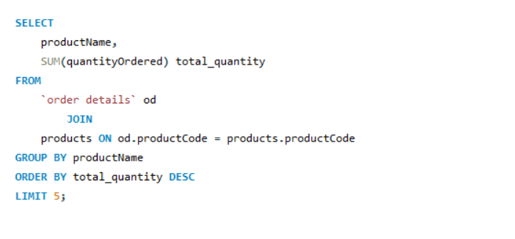

- 6. Compute the average quantity ordered per product.

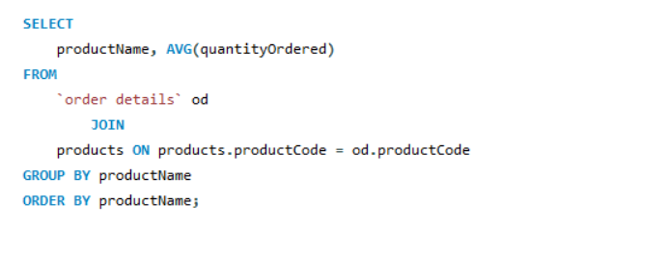

- 7. Determine the number of customers per sales representative.

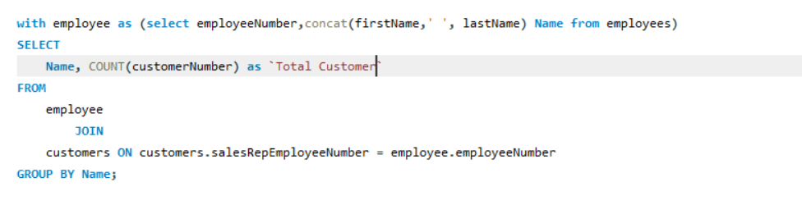

- 8. Identify top-performing employees based on revenue.

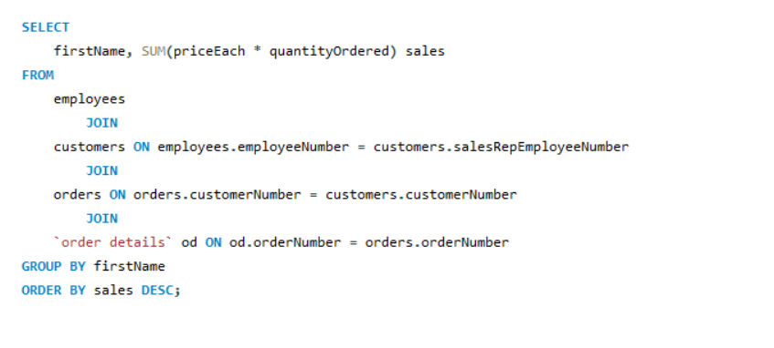

- 9. Compute average customer credit limit by country.

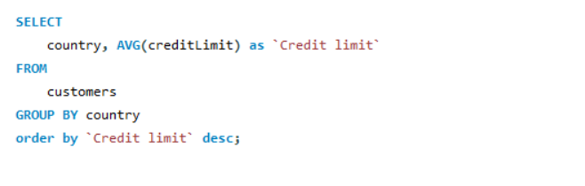

- 10. Analyze payment trends over time.

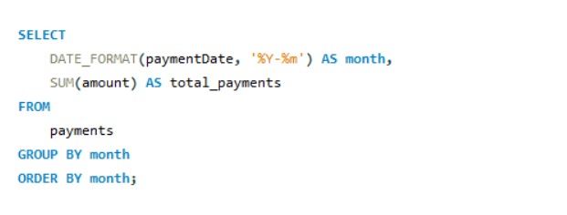

11. Determine the top five customer generating the highest revenue.
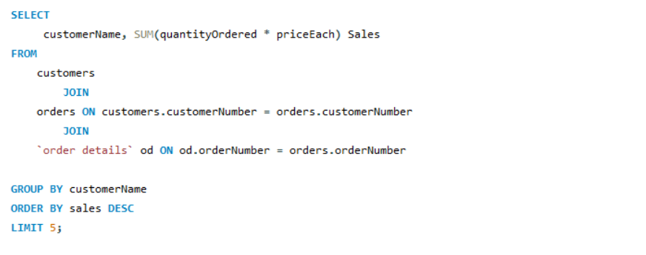

12. Detect products running low in stock.

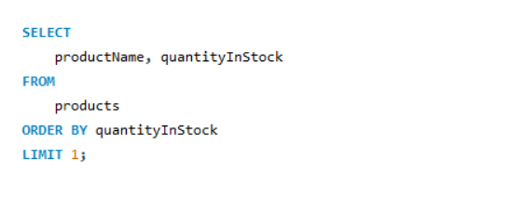

- 13. Identify the month with the highest number of orders.

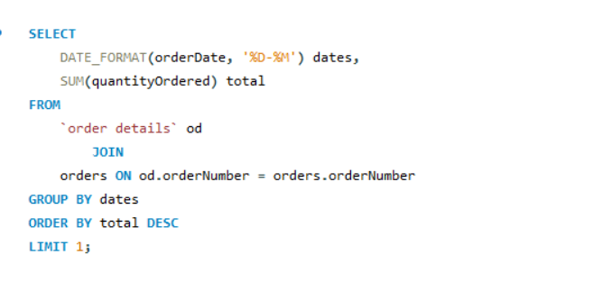

- 14. Find the city with the highest number of customers.

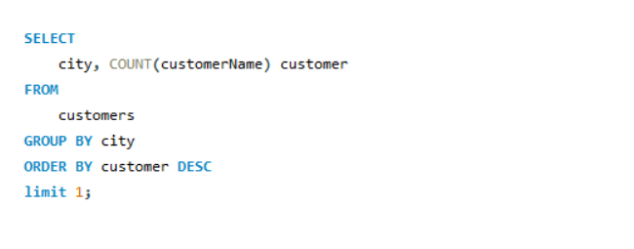

- 15. Identify most frequently used check numbers in payments.

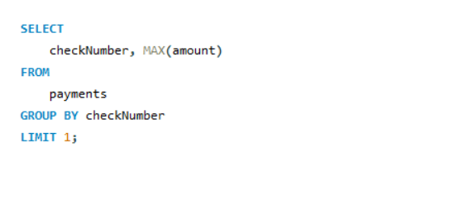

Dashboard
To provide a real-time view of key performance indicators (KPIs) related to product sales, order status, customer payments, and regional performance for the Classical Automobile dataset. The dashboard enables stakeholders to make quick, informed decisions.
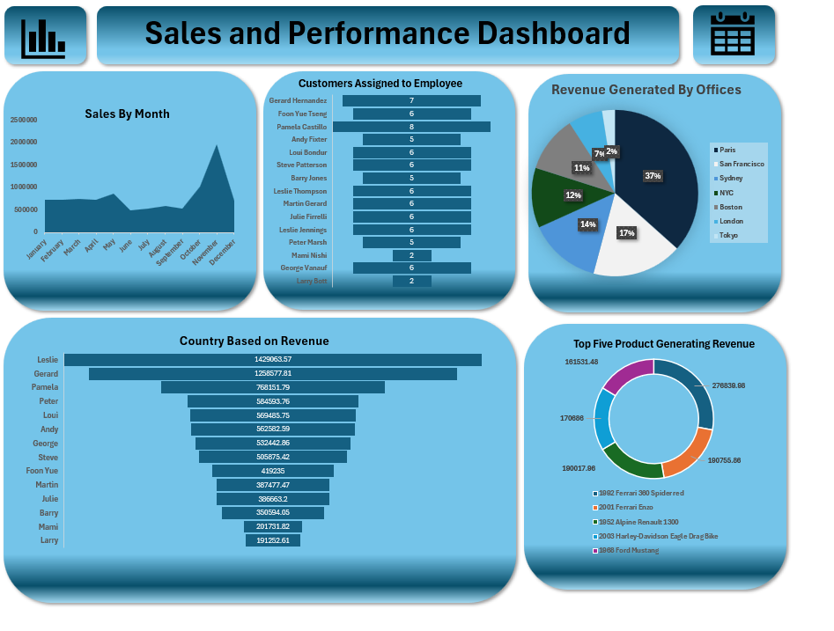

Key Insights
The analysis revealed key revenue periods, identified high-value customers and top-performing employees, highlighted low-stock products, and showed geographical trends in customer distribution and credit limits. These insights are crucial for inventory management, sales strategy, and resource allocation.

Project Outcome
This project provided a comprehensive overview of the business using the Classical Automobile dataset. It offered valuable insights that can guide decision-making in marketing, logistics, customer service, and sales.

Challenges Faced
• Joining multiple tables with complex relationships.
• Handling data quality issues such as duplicates.
• Ensuring accurate aggregation and formatting of date/time fields.
• Structuring queries for optimal performance and readability.

Learning Points
• Mastery of advanced SQL concepts including joins, aggregations, and formatting.
• Practical application of business analysis through SQL.
• Understanding of how to derive actionable insights from structured data.
• Gained experience in presenting SQL findings in a business context.

